***Static variables***

*We can use static with class level variables not local variables*

*Methods*

*Blocks*

*Inner class (Nested class)not outer class*

*Class level we can use not as local variable not object level*

*Class Test{*

*Static int a;-----------🡪class level static variable*

*Void show(){*

*Static Int a;------🡪wrong declaration of static local variable; illegal start of expression*

*}*

*}*

*In 2 classes, can class static by class in main method.*

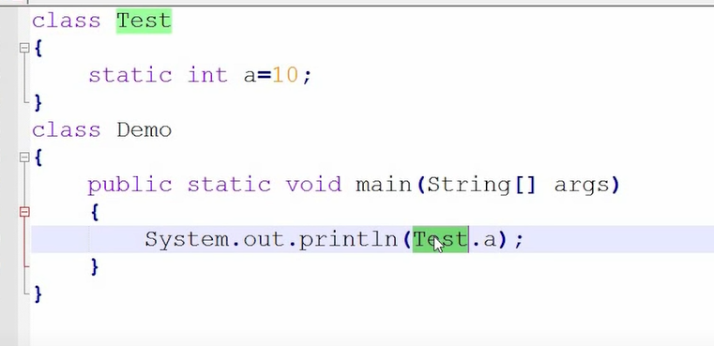

***use***

*🡪memory management*

*(This---current class instance variable)*

*Here SP is same in all the object memories e1,e2…... its wasting memory.so declare SP variable as static.*

*When a variable is declared as static, then a single copy of variable is created and shared among all objects at class level. So company name ie SP will be shared among e1,e2 and all the objects.*

*If any value is common, then we can make that variable as static variable for memory management.*

*Eg: college name ,employee name, Company name*

*Static variable- will get memory🡪in class area at the time of class loading*

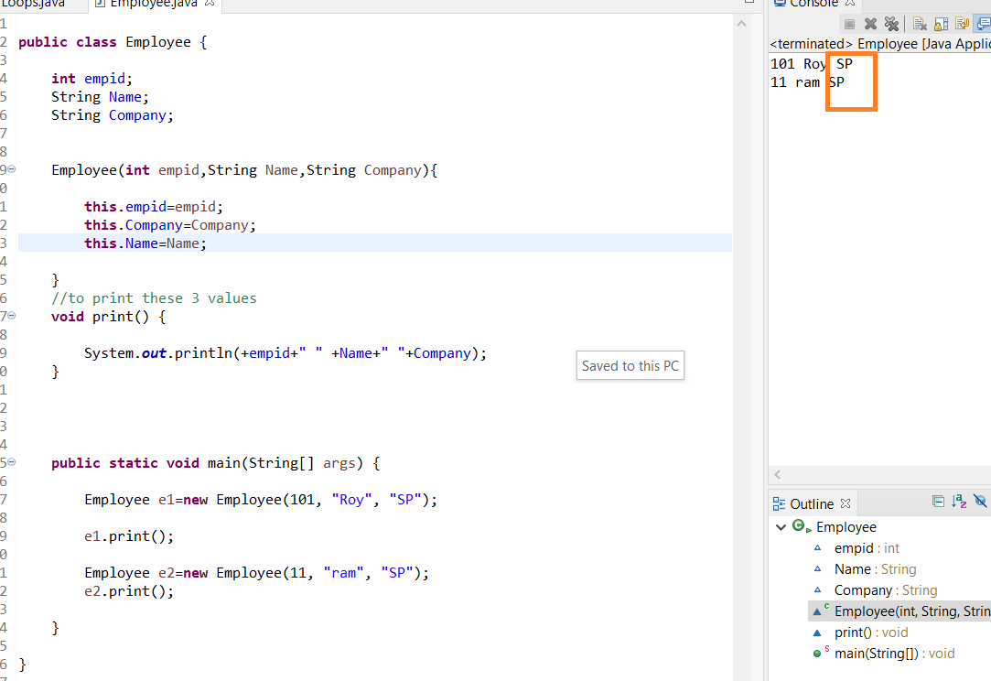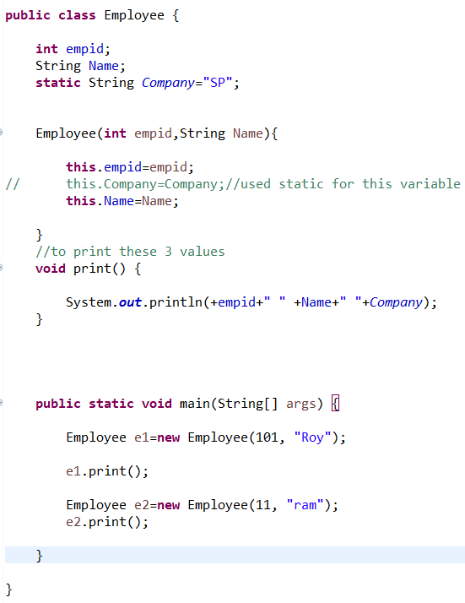

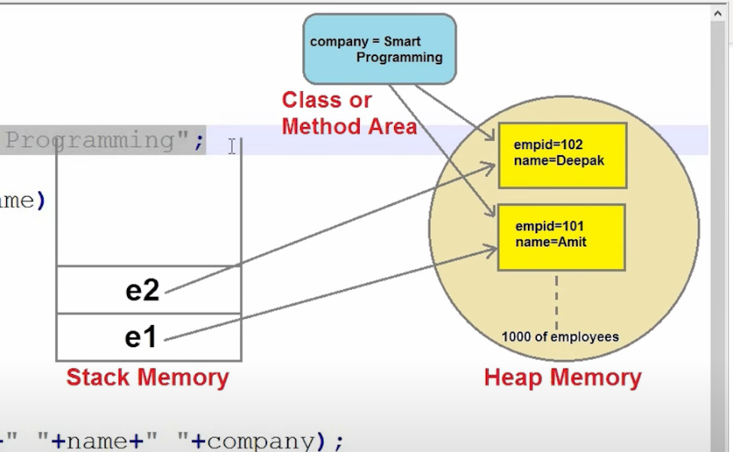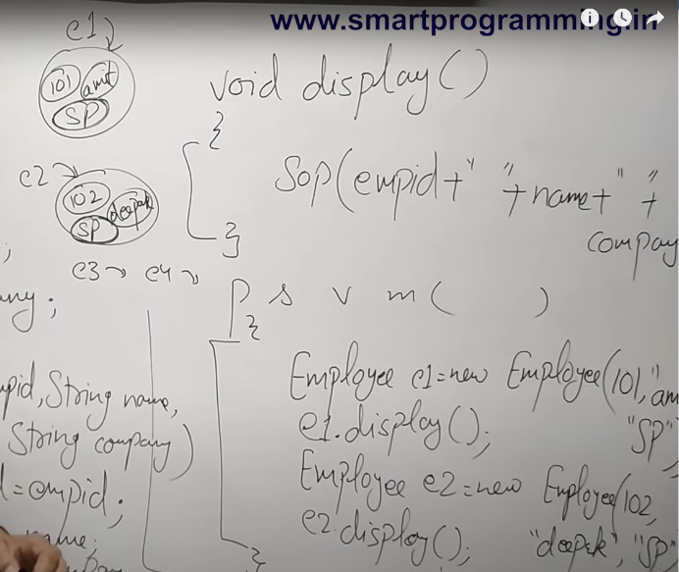

*Since the count is initialized as instance variable each object will take same value when calls constructor .It won’t be incremented.*

*Flow—constructor calls—so created CounterDemo constructor. When 1st obj created count value get initialize+increment so 1*

*Then for c2==same 0and then 1 and so on.*

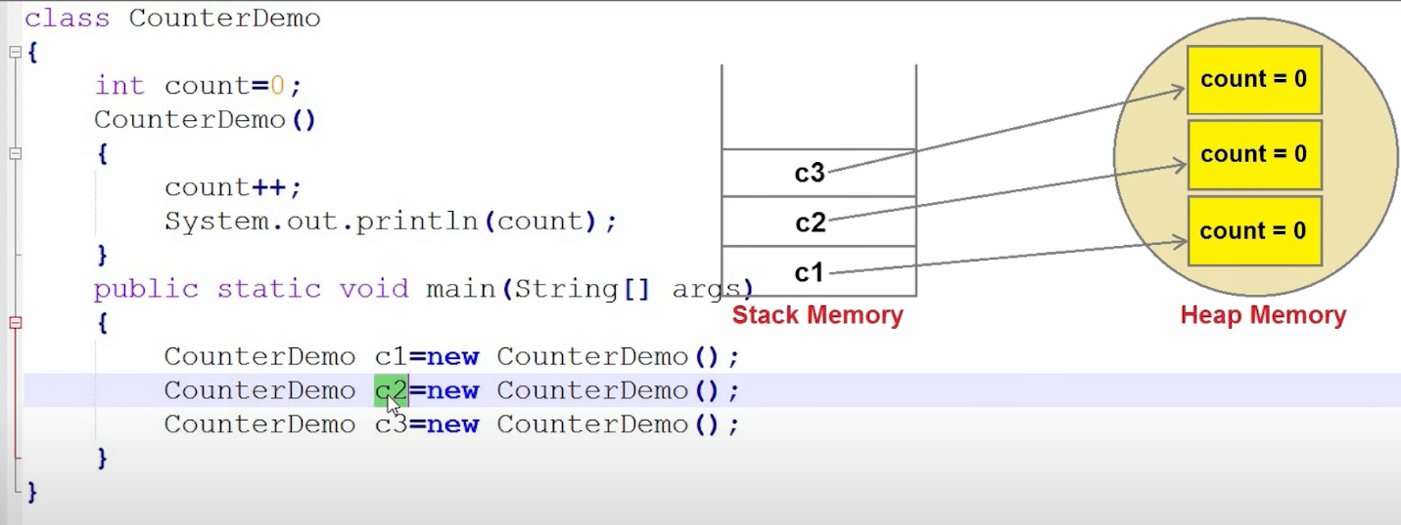

*When changed to static, count value is not for obj c1,c2 and c3 ,it will take as class level which means for CounterDemo class. So when create object for the class count value 0 will be shared to objc1 and incremented value will be printed. Next for c2---2(last value 1)*

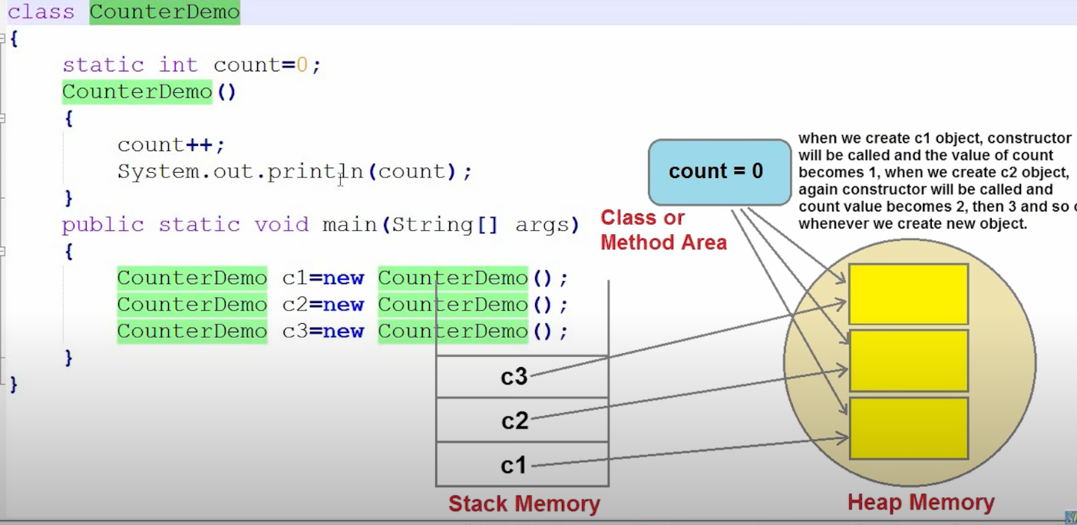

***Static methods***

***Mainly memory management***

Why use static keyword in method🡪static method belongs to class not to object---so no need to create object to call a static method. So s/w speed will be fast.

When creates object, it will take memory.

If its in a same class.. can call without classname. Or with class name

Different classes--- classname. static method name

